FORM 2 THE PATENTS ACT, 1970 (39 of
1970)
and
THE PATENTS RULES, 2003
COMPLETE SPECIFICATION
(See section 10 and rule13)

TITLE OF THE INVENTION

AI-Driven Nutritional Assessment for Packaged Foods

APPLICANT (S)

Dr. D. Y. Patil Institute of Technology, Pimpri, Pune - 18
PREAMBLE TO THE DESCRIPTION: -
THE FOLLOWING SPECIFICATION PARTICULARLY DESCRIBES THE NATURE OF THE INVENTION AND THE MANNER IN WHICH IS TO BE PERFORMED
COMPLETE

- Field of the Invention: -

The present invention pertains to a mobile application that analyzes the nutritional content of packaged food products and the ingredients that go therein. The application inputs image recognition and artificial intelligence(AI) to understand the information read from images of the back side of food packaging. An API key is utilized in the application for calling an AI model, which accepts the captured image as input, analyzes it, and extracts nutrient and ingredient-related data. This extracted data undergoes analysis for identifying vital nutritional information like sugar content, detrimental ingredients, and healthiness altogether. This information is incorporated within the application, which provides a simple interface that goes with it and rates that food based on the analysis. The invention serves to provide the convenience of nutritional information and accessibility to let consumers make informed food choices in favor of healthy eating. The invention thus contributes to advancements in personal health management and application of AI technologies into everyday life.

Background of the Innovation: -

Preamble to the Description

1.Camera: Takes an image of the back side of the package of food with nutrition facts as well as ingredients.

2.Pre-Processing Module: Pre-process the captured images that extracts relevant information such as text and layout enhancement or digitizing, Optical Character Recognition (OCR) may be applied.

3.API Integration Module: Securely connects the data to a cloud AI model using API keys. It transmits the processed image data as an input to the AI model for analysis.

4.AI Model (Cloud-based): A strong AI model trained to recognize and interpret food labels. It analyzes the image data to extract additional nutritional details-generally, calories, 5.fats, carbohydrates, protein, vitamins, as well as its minerals, etc., as well as the full ingredient list. The model was also trained to trace any potentially harmful ingredients (eg, artificial sweeteners, trans fats, allergens).

6.Data processing module: The return data will be processed further by this module. It calculates "key nutritional metrics," marks those with assumed high sugar, sodium, or unhealthy fats levels, and finally points out if any of the ingredients are harmful or allergenic. A proprietary algorithm analyzes food's nutritional profile based on extracted data, including macro/micronutrient balance, harmful ingredients, and dietary compliance, to generate a rating (score, grade, or stars). The User Interface Module then presents this data clearly, highlighting key nutrition facts, concerns, and the final rating.

Electronic System/Software Architecture :

In fact, this application is very much modular; and most core functions exist in a cloud environment. The heavy lifting work of the image analysis and data extraction is done by an AI model. The mobile application only takes an image, sends it to the cloud via the API, receives the analyzed data, and makes it available for viewing to the user. It also keeps the user's preferences (like dietary restrictions, allergies, etc.) locally, but all analysis and rating calculations are performed on the AI cloud model through the API. Thus, the API becomes the important and critical bridge between the mobile app and the powerful AI engine in the cloud. The architecture also allows for efficient processing, scale, and easy updates of the AI model without updating the application.
- Summary of the Invention: -

The mobile app scans the back of packaged food for its nutrition and ingredient information. With image recognition, the mobile app takes a picture of the nutrition facts label and ingredient list on the food packaging. The app uses API keys to interact with a cloud-based AI model that processes the image and extracts the nutritional information and ingredients. Also, it analyzes the extracted nutritional information and ingredients and correlates them to some key parameters, including high sugar, unhealthy fats, high sodium, and harmful or allergenic ingredients. The app also rates the food according to these metrics, allowing consumers to easily assess the nutritional quality of a product. Thus, the invention allows consumers to make the right food choices by providing insight into actionable steps that lead to better diets while furthering the consumers' knowledge surrounding potentially harmful ingredients. Its applications include personal health tracking, diet management, and educational tools to increase knowledge of nutrition.
- Prior Art Search: -

Allergens and Nutrients in Fruits and Packaged Food Using Deep Learning and OCR (2021 IEEE) – A mobile-based framework utilizing deep learning and OCR for fruit classification and allergen extraction from food labels, achieving 96.6% accuracy. Open-sourced via a web application but limited by Pytesseract’s effectiveness on complex packaging.

Android Application for Food Label Recognition (2023) – Nutricare, an Android app for allergen detection in packaged foods, with a 91% OCR accuracy and 99% allergen detection success. Uses Google's Vision API and a JSON-based allergen database but has a limited food database and OCR inconsistencies.

Consumer Safety via OCR on Product Ingredients (2023 IEEE) – A system combining OCR and barcode scanning to assess ingredient safety per FDA regulations with 89% accuracy. Utilizes deep learning, semantic search, and NLP to detect hazardous substances but lacks stated limitations.

Automated Nutritional Claims Verification (2024 IEEE) – Uses OCR and machine learning to verify nutritional claims, employing EasyOCR and Deep Decision Tree Classifier (85% accuracy). Faces class imbalance issues and could benefit from refined nutritional thresholds.

Brief Description of Drawing:

The organization, as demonstrated through the block diagram, entails the analysis of packaged food images via Optical Charac-ter Recognition (OCR) and additional evaluation. What follows is a brief description of the various figures and their connections:

1. Capture Image of Package Food (201):

- The process commences by taking a picture of packaged food with a camera or a mobile phone.

2. Upload Image on App (202):

-The image is uploaded onto an application for processing.

3. Processing Image (203):

- The uploaded image gets processed so that clarity is enhanced, the extraction of textual information relevant to the task.

4. Extract OCR Information ( Google vision/ Paddle OCR) (204):

The extracted images through Optical Character Recognition (OCR) key information, involves :

-Table of nutrients (205) – extracting nutritional information from the packaging.

-Ingredients (206) - This refers to the extraction of ingredients mentioned on the pack.

-Food Type (207) - categorize the type of food product.

5. Analysis (208):

Aspects that involve the processed information include.:

Harmful Effects on Health (209): This refers to assessing any detrimental health effects.

Nutrition Value (210):This refers to of the general nutritional value of the product in question.

Harmful Ingredient (211):This unravels assessing ingredients that may be harmful.

Food Rating Based on Singapore Standard (Block 6.2.1): This assesses the rating using nutritional standards.

Excess Sugar Control (213): This includes screening excessive sugar and related health issues.

6) Detailed Description of the Preferred Embodiment: -

This fully portable mobile application-integrated food analysis system implements synergy and use of a couple of important elements for easy and effective food analysis. Below is the process description followed by the detail of elements involved:

1. Image Capture Module (201): Placement : Mobile camera interface Function: It captures images of food products in packages Operation: A user captures the image via their mobile device when they intend to analyze food.

2. Image Upload Component (202): Placement : Inside mobile application Function: Manages image transfer to processing system Operation: Transfers the captured image to the system for processing.

3.Processing Unit(203): Function: Processing the uploaded image for OCR extraction Operation: Prepares the image for thorough text and data extraction.

4.OCR Information Extraction (204): Placement: Core processing system Faultless: Three forms of extracted data- nutrients table(205), ingredients(206) and food type(207) operation: Scans and extracts important information from processed images via Google Vision/Mobile OCR.

5.Analysis Engine (208).Location: Central processing unit: Purpose: Conducts in-depth analysis of data extracted Operation: Analyzes data in five parameters:

Adverse impact on health (209)

Toxic ingredients (211)

High sugar level (213)

Nutritional value (210)

Food rating against Singapore standards (212)

6.Central Management System(214): This system receives data from the OCR extraction and other sources, controls analysis, and creates the final output. Operation: The system extracts and analyzes data from the OCR and finally delivers the data to the mobile user interface.

7) Object of the Invention:

• Nutritional Information Extraction: The extraction of nutritional ingredient data from the backs of packaged foods should then create high-efficiency and accurate analyses based on advanced image recognition and artificial intelligence models without the need for user input.
• AI-Powered Analytics: A robust API key coupling to the AI model integrated with the captured images of nutrition labels and lists of ingredients as they provide real-time determining metrics for high sugar, harmful fats, sodium counts, or allergen ranki
• Personalized Food Rating System: Automated and intuitive food rating scheme on nutritional analysis will give mean intuitive scores that will communicate an end-product healthiness.
• Seamless User Experience: The user experience will improve with quick scans and immediate analysis in one central place with all developed comprehensive information on foods for better nutrition through accessible technologies.

8) Obviousness : -

By means of its mobile application utilizing state-of-the-art image recognition technology, the system will enable users to scan the back of packaged food. After the user snaps a picture of the nutrition facts label and ingredient list, that data will be passed onto an AI model connected via API keys for processing. The AI will analyze how nutritious the food is with respect to excessive sugar, unhealthy fats, and harmful ingredients. The app will also generate a food rating according to the analysis, guiding users in their dietary choices. Through this system, access to nutritional information is made easy, enabling healthy choices.

9) Non-Obviousness : -

Simply put, the obscurity of a food packaging scanning mobile application comes from its integration of advanced AI and image recognition technologies to detect nutritional information. Unlike other ways that require reading labels with great effort, it may therefore be most suitable to see the app as just taking images of food products with important data like sugar limits, unhealthy ingredients, and nutri-values. The app analyzes and rates the food in real time so that users get tailored feedback, which fosters healthier choices and educates users on the detrimental health effects of the ingredients, all in a timely and convenient manner.

10) Novelty: -

A new facet of this project is the unexpected capacity of the AI-based image recognition technology supplemented with food packaging analysis to fit together. By scanning the back of packaged food items, the application will not only look for and identify nutrients but it will also flag hazardous elements and exorbitant sugar content. This approach steers the way otherwise complex task in the food labelling sector become understandings for the smooth knowledge of learning and the individual's preferences for specific food brands. By integrating between a convenient space and sophisticated technology that help promoting healthy eating, the method becomes a new way to nutritional consciousness and at the same time fosters knowledgeable food choices among the consumers..

11) Industrial Applications: -

These provide, indeed, an automated, AI-powered analysis for consumers on personalized nutrients, as well as scanning food labels to match better choices to their diet.

Real-Time Nutritional Tracking: Allows health and fitness applications to connect with real-time-use reporting on daily intake of nutrition to optimize diets and wellness.

Compliance with Food labeling regulations: It provides set parameters to food manufacturers and regulatory agencies by ensuring that their products meet nutritional labeling standards, thereby reducing non compliances.

Consumer education: This is intended for wide consumer learning in nutrition by providing an easy comprehension rating system for foods, alerting about ingredients and ratios of sugar and other harmful additives in packaged food.

- I/we claim :
Claim 1: A method for real-time analysis of food package ingredients using image-based AI.
Claim 2: A technique for food product of the exact food and feeding of animals for example using cloud-based AI processing via API integration technology means that the dosing can be controlled and the required dose can be given to the animals such that the milk is regulated and milk production improvement will be achieved.
Claim 3: A method for extracting nutritional information from food packaging and sending it to the cloud via API integration in order to analyze it.
Claim 4: A system that is more advanced than a barcode scanner and can not only analyze real-time ingredient but also detect the presence of hazardous substances.

Sr. No. | Name of Inventor(s) | Sign
1 | Ms. Shubhangi Vairagar | 
2 | Tanmay Patil | 
3 | Rohit Mane | 
4 | Rishikesh More | 
5 | Tushar Chattarki | 

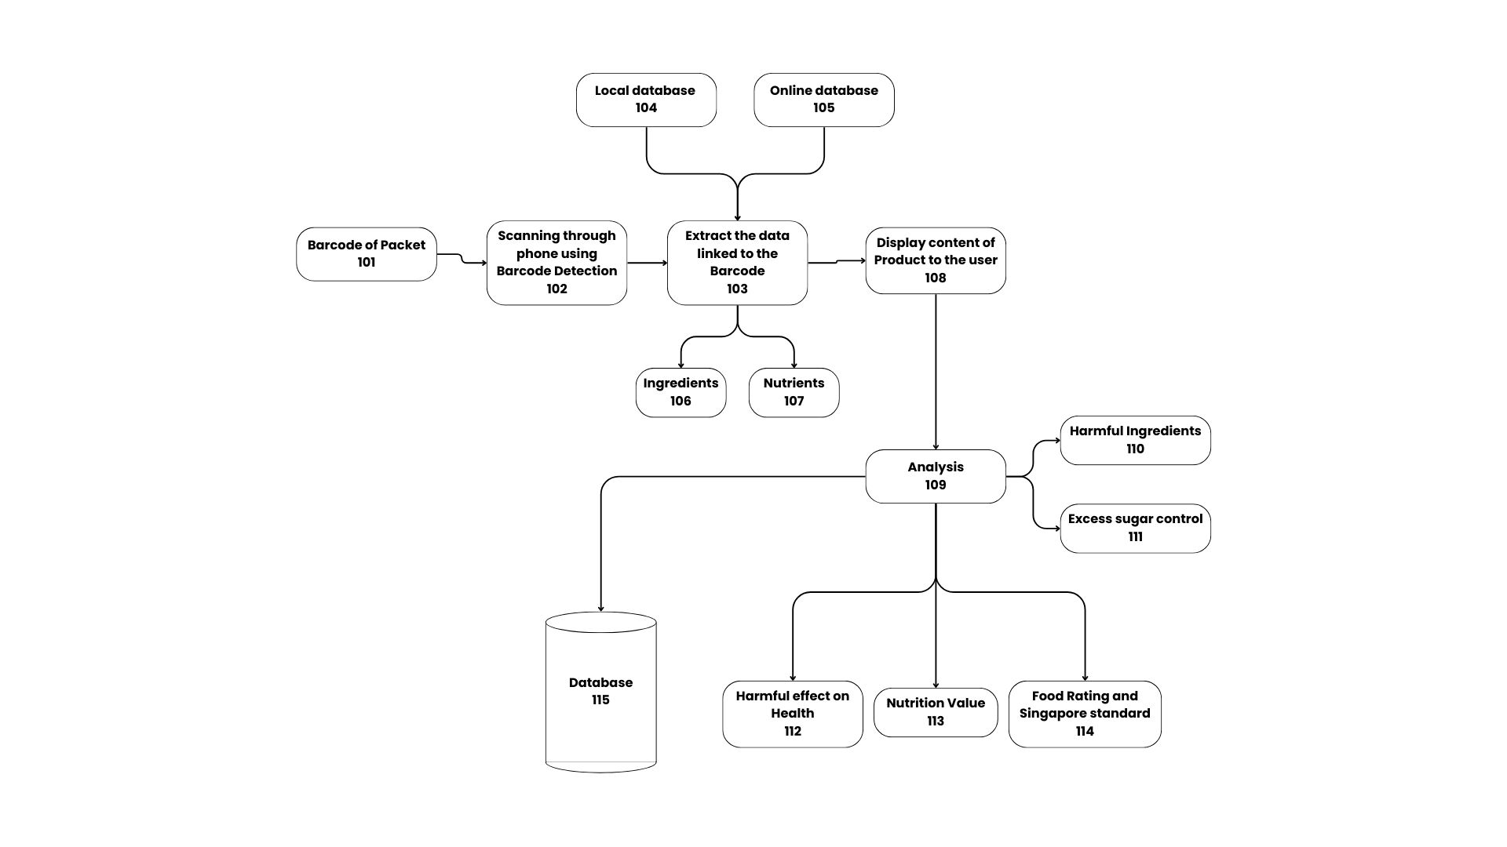
Drawing 1 of 2: Block Diagram To Display And analysis of product using barcode :

Sr. No. | Name of Inventor(s) | Sign
1 | Ms. Shubhangi Vairagar | 
2 | Tanmay Patil | 
3 | Rohit Mane | 
4 | Rishikesh More | 
5 | Tushar Chattarki | 

Drawing 2 of 2: Block Diagram for “ AI-Drive Nutritional Assessment for Packaged Foods ”
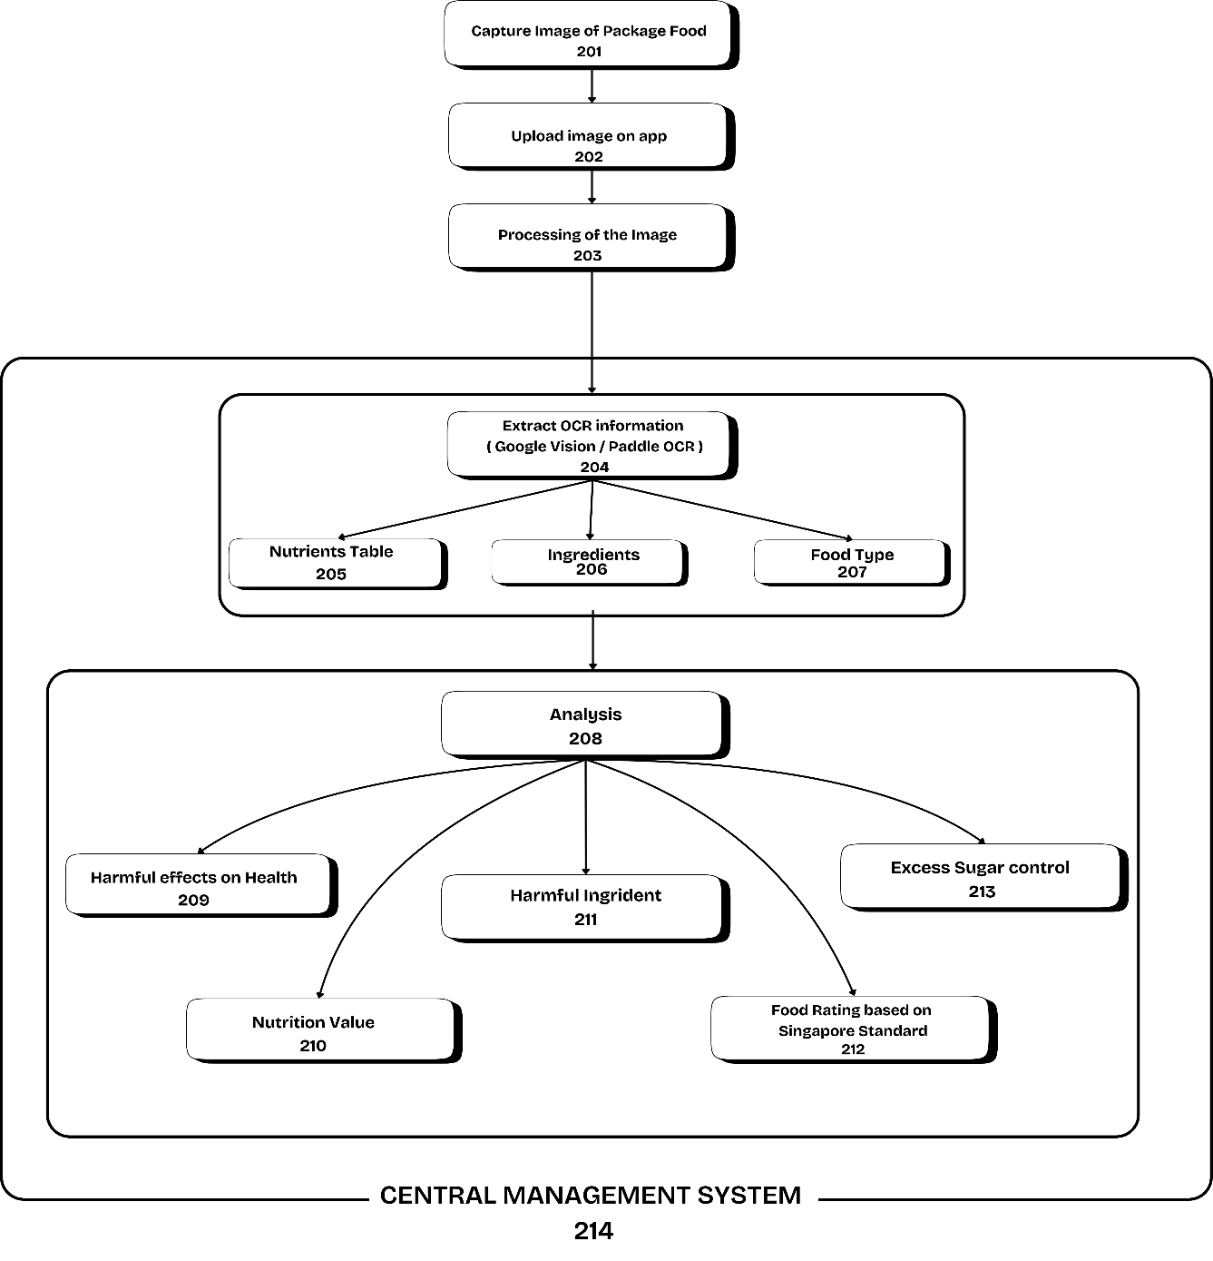
Sr. No. | Name of Inventor(s) | Sign
1 | Ms. Shubhangi Vairagar | 
2 | Tanmay Patil | 
3 | Rohit Mane | 
4 | Rishikesh More | 
5 | Tushar Chattarki | 

Abstract:

The present invention relates to a mobile application that scans the back of packaged foods to give nutritional value in detail. The app employs advanced image recognition technology and AI models to analyze the food label automatically and pull out nutrient, ingredient, sugar, harmful additives, and allergen information on these key parameters from the label. By linking to the cloud-based AI system using API keys, the app provides real-time analysis of the photos of the nutrition facts label and ingredient list for all obtained insights. The app provides layman ratings for food, focusing on unhealthy contents and available healthier options based on analyzed data. The overall aim of this system is to ease understanding food labels and provide encouragement for good eating practices that will help users make good eating decisions. In addition, the app turns out personalized recommendations about products that are good for individual health goals, hence its importance to health-conscious consumers. The system can also integrate with other fitness and health applications to guide users in wellness management. This invention collectively addresses challenges users face in understanding food labels that are typically complicated and provides them with simple information to be acted upon regarding better health management. The proposed solution is more scalable and flexible, given that it can be catered for different regions, types of foods, and consumer preferences.

Title : “ AI-Driven Nutritional Assessment for Packaged Foods ”

